curl --location 'http://uat-nsws-mnstrportal.investindia.gov.in/nsws_ack/acknowledgement' \
--header 'access-id: MIN_TEST_0' \
--header 'access-secret: MintesT@1234' \
--header 'api-key: Min1@A01' \
--header 'Content-Type: application/json' \
--data '{
"ackType":"L",
"requests": ["SW1363001508-M008_D001_A014-1641369278639"],
"ministryId":"M008",
"deptID":"M008_D001"
} '

-----------------------

Summary: NSWS Acknowledgement API (/nsws_ack) — Ingress misrouted to incorrect backend service in UAT
Environment: UAT (uat-nsws-mnstrportal.investindia.gov.in)

Description:
Issue:
The /nsws_ack/acknowledgement endpoint was returning 404 Not Found when accessed via the UAT ministry portal hostname, despite valid credentials (access-id, access-secret, api-key) and a correctly formed request payload.

Investigation:

Verified the request payload, headers, and credentials were correct.
Confirmed the issue was not client-side (tested via curl and Postman with identical results).
Bypassed DNS/hostname and hit the backend directly via internal IP (192.168.47.100:8035) — same 404 observed, ruling out DNS resolution issues.
Inspected discovery/introspection endpoints (actuator/mappings, v3/api-docs) — locked down, not accessible.

Described the ingress configuration and found the /nsws_ack path was incorrectly mapped to:

svc-tcs-uat-docker-nsws-bis-architecture:80 (192.168.44.65:8044)

instead of the correct target service:
svc-preprod-uat-docker-nsws-api-gateway

Root Cause:

Ingress rule for path /nsws_ack was pointing to the wrong backend Kubernetes service (nsws-bis-architecture instead of nsws-api-gateway), causing all requests to this path to be routed to a service that does not expose the /acknowledgement route.

Resolution:
Updated the ingress mapping for /nsws_ack to point to svc-preprod-uat-docker-nsws-api-gateway. Verified via both the internal IP endpoint and the API gateway endpoint — both now return 200 OK with expected acknowledgement response payload (ackNo generated, request-ID validation working as expected).

Verification:
POST /nsws_ack/acknowledgement
Response: 200 OK
{
"status": "200",
"message": "IDs Under Failed List Could Not be acknowledged as Request ID not found!",
"response": {
"ackNo": "ACK20260701142407M019",
"failedId": ["SW1363001508-M008_D001_A014-1641369278639:Request Not Found"]
}
}

Status: Resolved — ingress remapped to correct backend service.

Comamnds:
kubectl get ep -n tcs-uat | grep gateway
kubectl get ep -n tcs-uat | grep ack

kubectl get ingress -n tcs-uat
kubectl edit ingress internal-ingress-alb-react -n tcs-uat
kubectl describe ingress internal-ingress-alb-react -n tcs-uat

Curl commands in Postman
http://192.168.44.203:8001/nsws_ack/acknowledgement
(gateway with ms name)

http://192.168.47.100:8035/acknowledgement
(ms with ms name)

Screenshots:
404 error
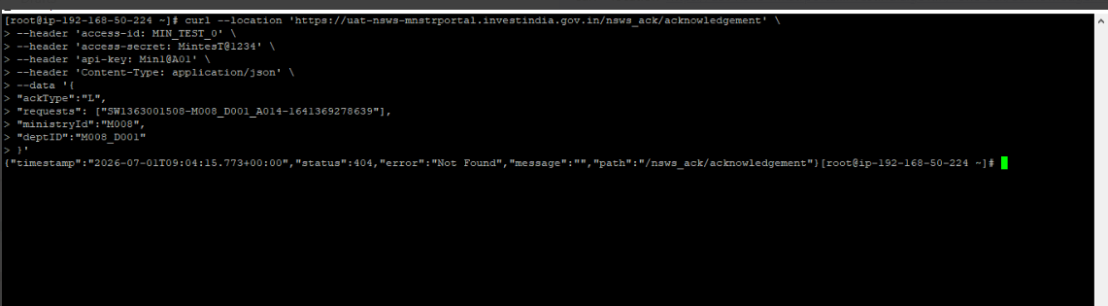

Ack mapped with wrong gateway (instead of gateway mapped with bis)
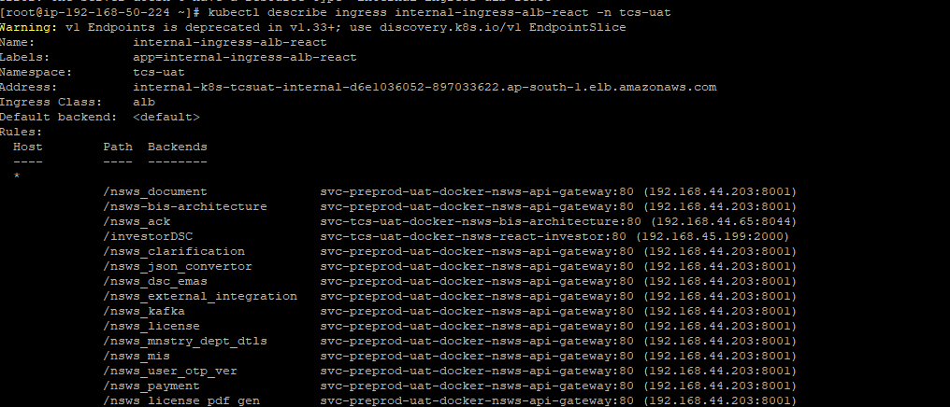

Mapped with gateway
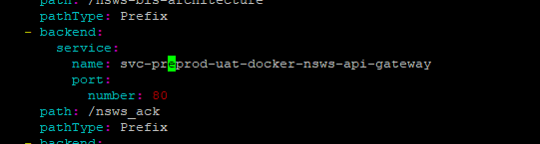
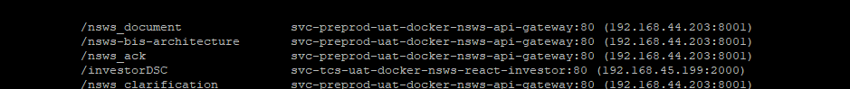

200 response code

